Following information is required for drafting of patent application.

1. **Full name, nationality and address of applicant(s):**

|  |  |  |
| --- | --- | --- |
| **Full Name** | **Nationality** | **Address** |
| Vishwakarma Institute of Information Technology | Indian | 666, Kapil Nagar, Kondhwa Budruk, Pune, Maharashtra 411048 |

1. **Full name (including middle name), nationality, address (VIT/VIIT address), mail id, and phone number of inventor(s):**

|  |  |  |  |  |
| --- | --- | --- | --- | --- |
| **Full Name (Including middle name) (Min. two faculty names)** | **Nationality** | **VIT/VIIT Address (Start with full dept. name followed by full institute name) (For ex.)** | **Mail ID** | **Phone No.** |
| Rajlaksmi Nilesh Desai | IN | Department of Electronics And Telecommunications Engineering, Vishwakarma Institute of Information Technology, Pune | rajlakshmi.22311732@viit.ac.in | 8605796792 |
| Samiksha Shailesh Nalawade | IN | Department of Electronics And Telecommunications Engineering, Vishwakarma Institute of Information Technology, Pune | samiksha.22311696@viit.ac.in | 9604107070 |
| Atharva Vishwas Deshpande | IN | Department of Electronics And Telecommunications Engineering, Vishwakarma Institute of Information Technology, Pune | atharva.22311679@viit.ac.in | 9309358950 |
| Manas Girish Kulkarni | IN | Department of Electronics And Telecommunications Engineering, Vishwakarma Institute of Information Technology, Pune | manas.22311608@viit.ac.in | 7972470825 |
| Revati Tushar Aute | IN | Department of Electronics And Telecommunications Engineering, Vishwakarma Institute of Information Technology, Pune | revati.22311517@viit.ac.in | 8208092760 |
| Dr. Pallavi Devendra Deshpande | IN | Department of Electronics And Telecommunications Engineering, Vishwakarma Institute of Information Technology, Pune | pallavi.deshpande@viit.ac.in | 9822269265 |
| Dr. Archana Kshitij Ratnaparkhi | IN | Department of Electronics And Telecommunications Engineering, Vishwakarma Institute of Information Technology, Pune | archana.ratnaparkhi@viit.ac.in | 8605432488 |

1. **Title of the invention:**

MediTag: RFID Based Smart Medicine Inventory System

1. **Technical field of the invention:**

RFID (Radio Frequency Identification), Medication adherence, Inventory management, Energy efficiency.

1. **Prior art:**

Ridita Garg et al. (2022) explored the implementation of an RFID-based clinical medicine dispenser to enhance medication management. The study demonstrated that integrating RFID technology significantly reduces medication retrieval time and minimizes errors, thus improving patient safety.

S. A. Ishak et al., (2016) proposed the Smart Medicine Cabinet Monitoring System that was made to persuade patients to take their medications using RFID technology. The device monitors the retrieval of medicines and sends notifications to remind about doses and frequency in a real-time manner. It is aimed to make medication adherence better by providing alarms for missed or incorrect doses, thus enhancing the overall compliance and health of the patients.

1. **Object:**

Patients often forget their medications, leading to health risks. MediTag solves this by sending real-time email updates when a dose is taken and alerts for missed doses, ensuring adherence to the schedule. By combining analog circuits with microcontroller automation, MediTag effectively monitors medication intake and manages inventory.

1. **Synopsis:**

MediTag helps patients manage their medications by sending real-time notifications when a dose is taken and alerts if a dose is missed, ensuring adherence to prescribed schedules. It uses RFID technology to track medications, tagging each container with a unique identifier that communicates wirelessly with the RFID reader. The system incorporates the ESP8266, a low-cost Wi-Fi microcontroller, enabling devices to connect to the internet for data transmission. A push-button switch optimizes power consumption by conserving energy during inactive periods.

MediTag stores medication data in a spreadsheet, giving users a complete record of their intake and inventory. This allows for easy sharing of data with healthcare providers and helps track usage trends over time. By integrating analog circuits, RFID technology, and data management, MediTag offers a reliable solution for monitoring medication adherence, managing inventory, and promoting energy efficiency.

1. **Brief description of drawings (if any):**

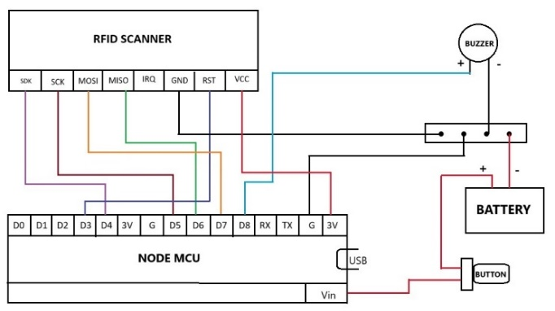

**Fig 1**

Figure 1 illustrates the circuit diagram

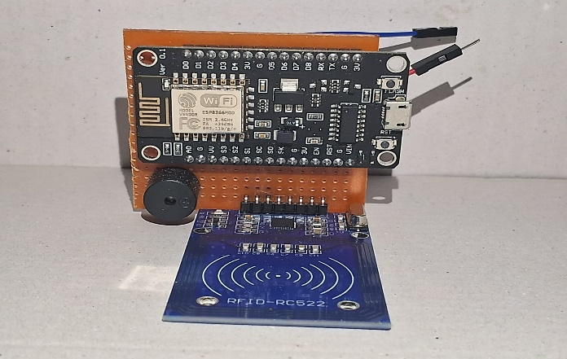

**Fig 2**

Figure 2 illustrates the PCB Setup

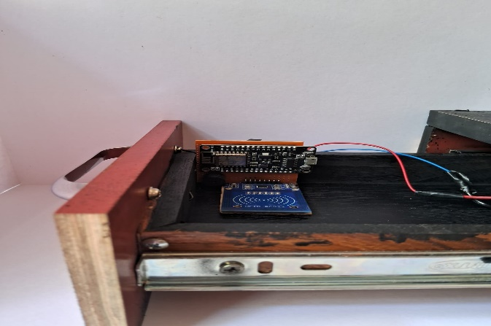

**Fig 3**

Figure 3 illustrates the internal Setup

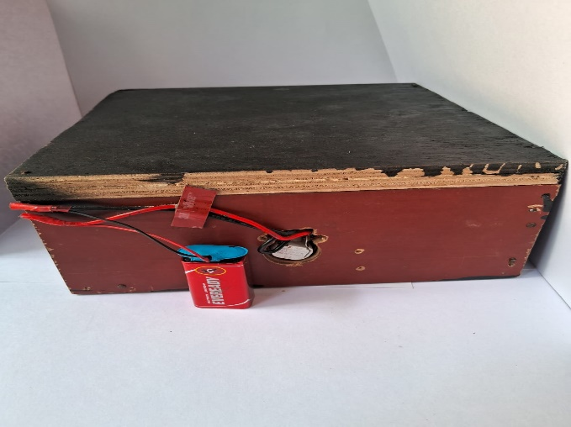

**Fig 4**

Figure 4 illustrates the hind part of the Setup

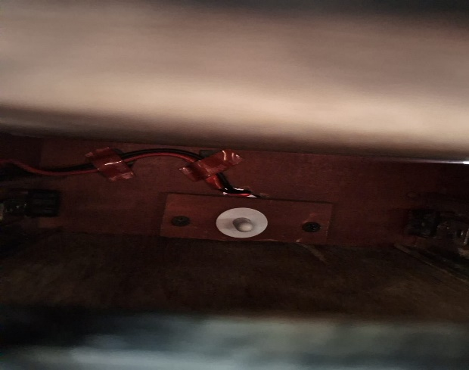

**Fig 5**

Figure 5 illustrates the toggle switch

1. **Detail description of the invention:**
2. **System Working**:

In our proposed system, we will utilize NFC Type 2 stickers to store specific medicine and email data for each corresponding bottle or strip. We have developed two sets of Arduino codes to facilitate this process. The first code is designed to store data onto the NFC Type 2 stickers, which will be affixed to the medicine bottles or strips. For power supply, a 9V battery is connected to the Vin pin of the NodeMCU. A push button is placed between the battery and the Vin pin to control the power supply.

When the drawer is closed, the push button is activated, opening the circuit and halting the power from the battery. Conversely, when the drawer is opened, power is supplied to the NodeMCU and the RFID scanner, making the scanner ready to scan the NFC stickers from a maximum distance of 30 mm. The second code will be uploaded to the NodeMCU, which is connected to an RFID RC522 scanner. To enhance functionality, we have integrated a buzzer that activates when the sticker is scanned by the RFID scanner during the retrieval of a medicine bottle. This alert serves to indicate that the patient has taken their medication, prompting an email notification to be sent to the patient’s relative. The data collected from the stickers by the RFID scanner is subsequently transmitted to Google Sheets via the NodeMCU.

1. **Functionality and Operation of System**:

The MediTag System operates as a smart, automated medicine management solution for patients. It is designed to streamline medication tracking and ensure patients take their medicine on time.

1. **Patient Information Entry**: Patients first fill out a Google form with essential details, including their name, email, mobile number, medication name, dosage time, and dose end date. This data is stored in the 'Form Responses 1' sheet in Google Sheets.
2. **Medicine Scanning and Logging**: Each time a medicine bottle or strip with an RFID tag is placed in the drawer, the RC522 RFID Scanner reads the tag and sends the tag information to the ESP8266 Node MCU. This data is processed and logged into a separate sub-sheet (Sheet2) in Google Sheets, storing the patient’s email, medicine name, and the exact timestamp of the scan.
3. **Data Matching and Visual Indicators**: If the medication name in both 'Form Responses 1' and 'Sheet2' matches, the system automatically turns the corresponding cell in Sheet2 green, signaling that the correct medication has been taken.
4. **Email Confirmation**: Once a match is detected, the system sends an email to the patient confirming that the specified medication has been taken at the noted time.
5. **Automated Reminders**: Based on the dosage time provided in the Google form, App Scripts triggers an email reminder to the patient daily, reminding them to take their medication. If no RFID scan is recorded, the system sends follow-up reminders as needed
6. **CLAIMS:**
7. **Push Button Switch**: The push-button switch controls power to the NodeMCU, activating the system only when the drawer is open. This energy-saving feature extends the 9V battery life by only powering the RFID scanner and microcontroller during use.
8. **Email Confirmation**: After the RFID tag is scanned, an email confirmation is automatically sent to the user, confirming that the medication has been taken. This ensures real-time tracking and enhances adherence.
9. **Email Reminder**: The system sends automated email reminders if a scheduled medication intake is missed. It checks the patient's dosage schedule and prompts the user to take their medication, improving compliance.
10. **Excel Database (Google Sheets)**: Medication data is stored in Google Sheets, serving as a database for tracking intake history. This allows easy access to records for monitoring and sharing with healthcare providers, supporting transparency and compliance.
11. **Inventive step of your invention:**

1. **Power Management Efficiency**: The ESP8266 Node MCU operates on a 9V battery (also works on DC 3.3V). A push-button switch at the back of the drawer disconnects power when closed, significantly reducing power consumption during idle periods and prolonging battery life.
2. **Error Recovery Mechanism**: The MediTag System incorporates several layers of error detection and recovery:

• *Error Logging for Debugging*: The system logs errors during critical tasks, helping identify failed operations for troubleshooting.

• *Status Columns in Google Sheets*: These columns track the success or failure of email tasks, allowing administrators to monitor email delivery status and take corrective actions if necessary.

• *Manual Error Handling*: Administrators can manually verify and resend failed emails, ensuring minimal risk of data loss or missed notifications.

1. **RFID Scanner Range**: The RC522 RFID scanner has an effective range of approximately 30 mm. This limited range ensures that RFID tags are only read when medicines are properly positioned near the drawer entrance, reducing the chances of erroneous scans and providing reliable inventory tracking.
2. **Industrial application:**

Healthcare Industry, RFID (Radio-Frequency Identification), Pharmaceutical Inventory Management, Supply Chain and Logistics

1. **Abstract:**

Elderly individuals often forget to take their medications, which can result in potential health risks. MediTag: Medicine Inventory (Smart Drawer) using RFID Scanner is a smart solution that promotes medication adherence by providing automated tracking and reminders. This system integrates RFID technology, Analog circuits, and Microcontroller automation to monitor medication inventory and send email notifications for both scenarios—when the medicine is taken and when it is missed.

We have utilized the ESP8266 microcontroller to facilitate communication and control the functioning of the RFID scanner, acting as a bridge between the spreadsheet software and the RFID scanner. Additionally, the system uses an energy-efficient push-button switch to optimize power consumption. MediTag simplifies medication management and helps patients take their medications on time.

1. **Drawing**